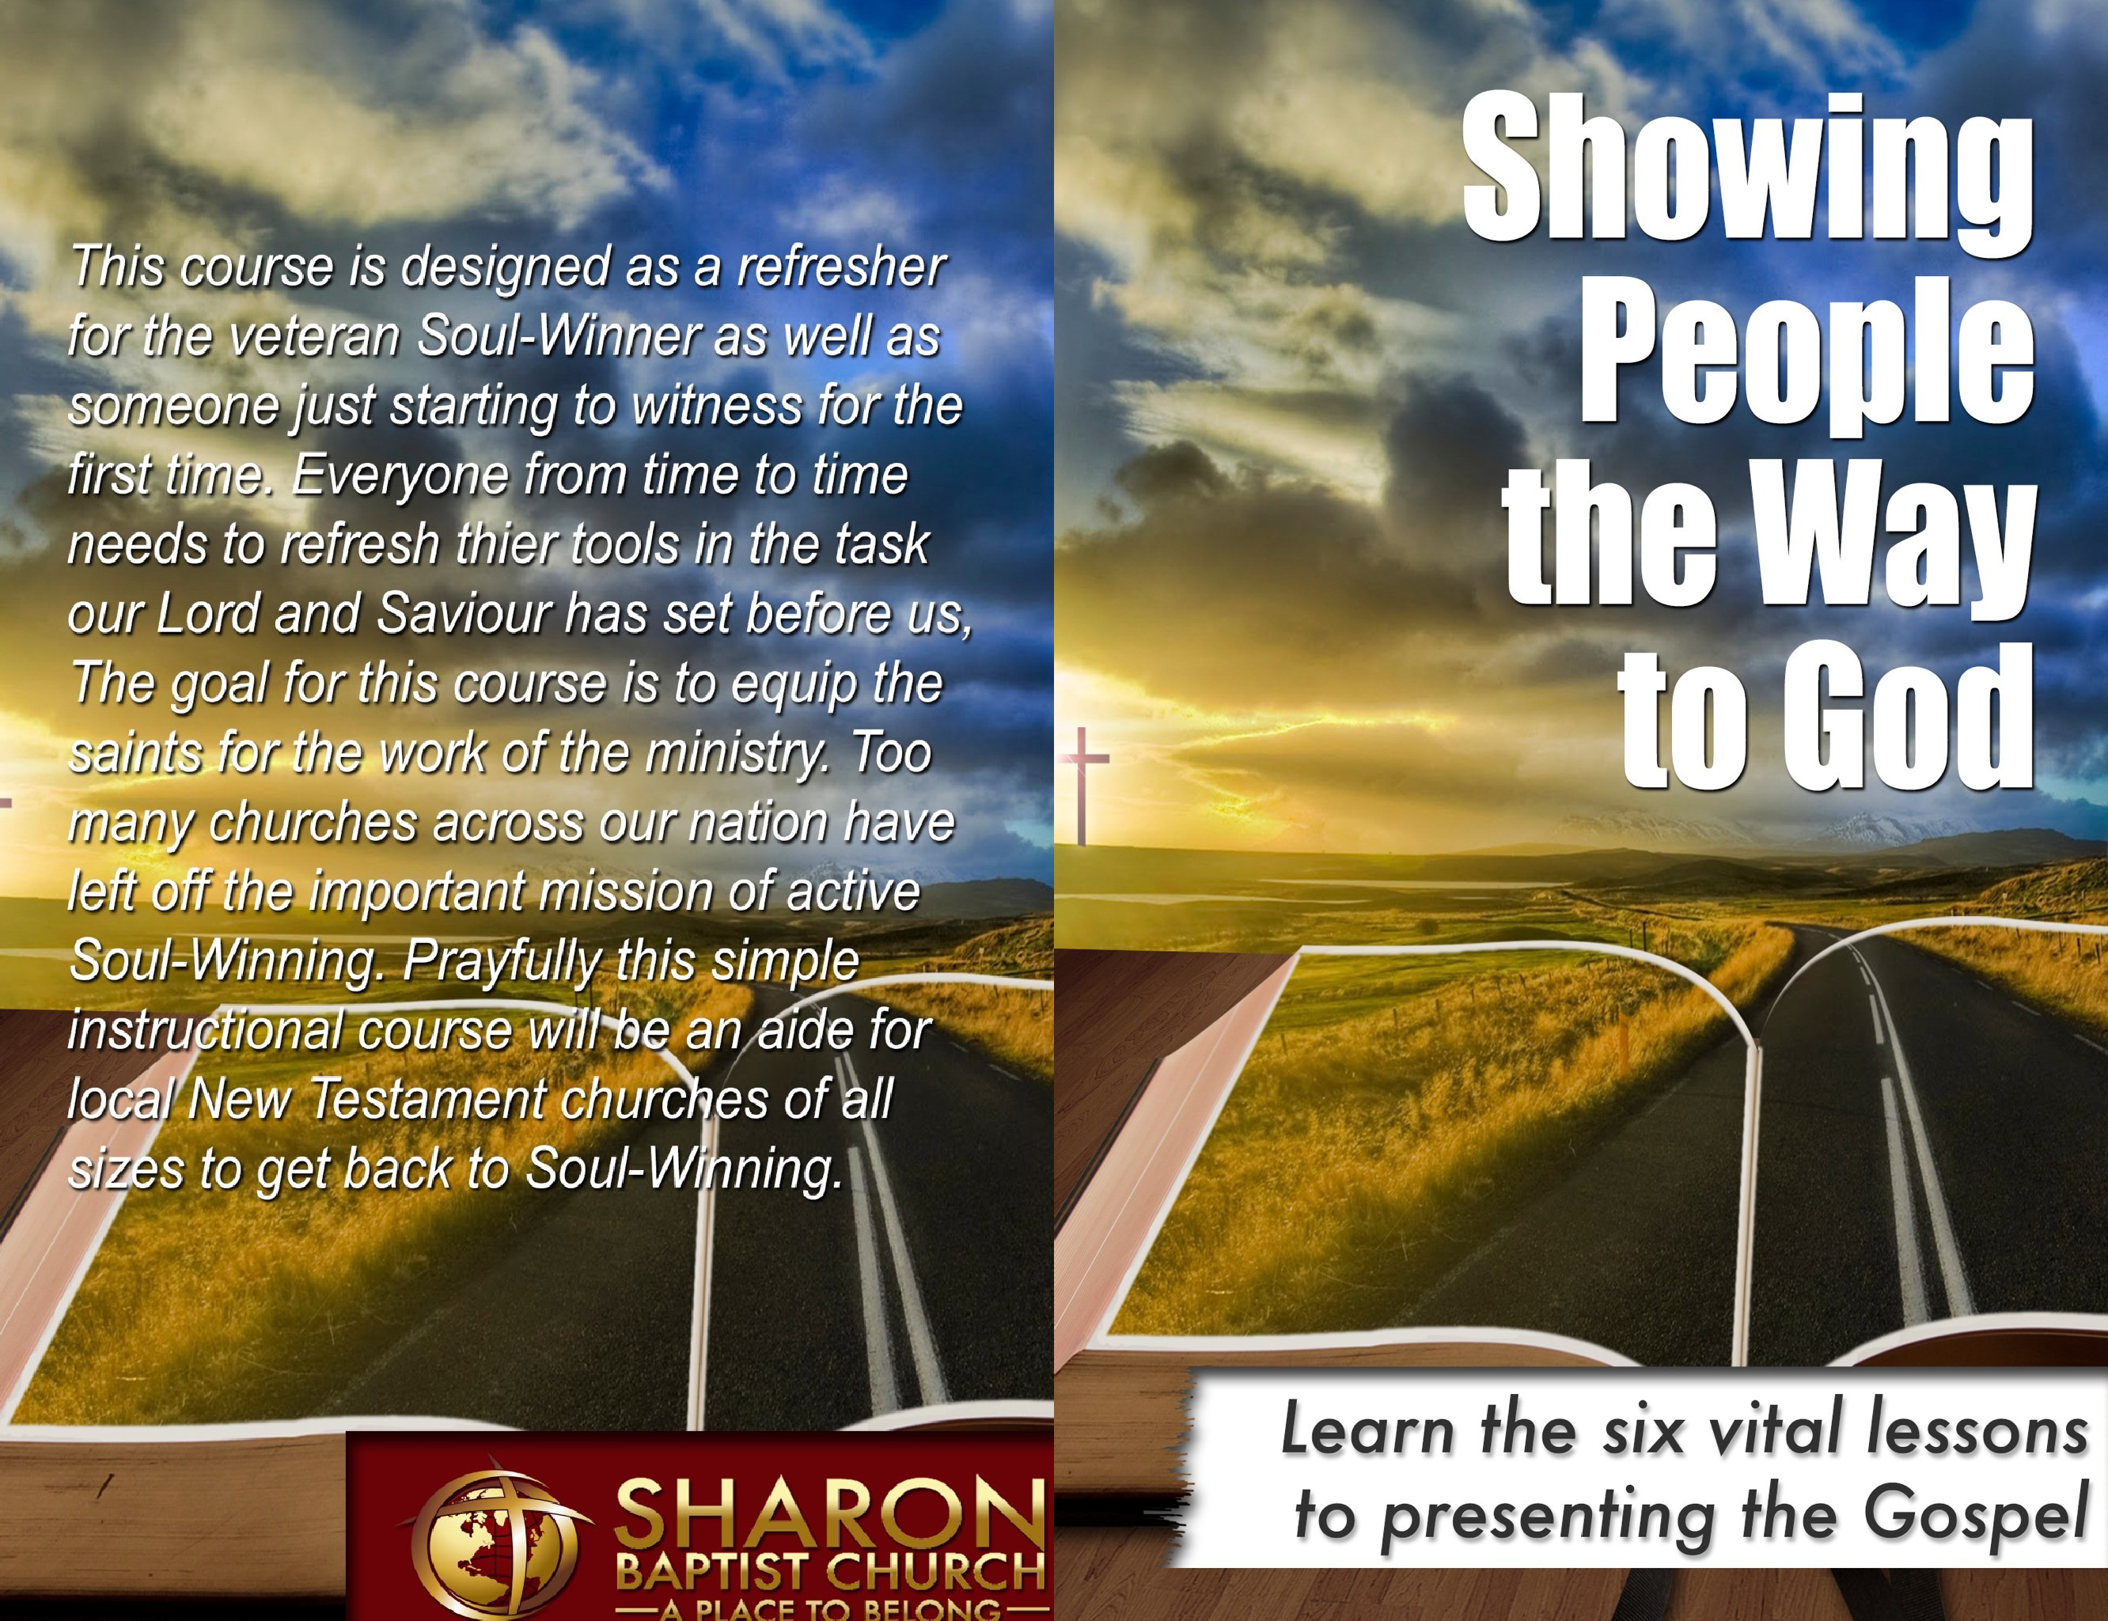
James Grandinetti Showing People the Way to God

40

Please also take the time to use the following links to extra resources:

www.SharonBaptistHamptonVA.com/soul-winning-refresher.html
Audio and Video of the Four Day Course we did at Sharon Baptist Church

Soul-Winner’s Refresher Course Copyright © 2017 by James Grandinetti.

All rights reserved. Printed in the United States of America. No part of this book may be used or reproduced in any manner whatsoever without the written permission except in the case of brief quotations em-bodied in critical articles or reviews.

All scripture quotations in this book are from the King James Bible.

For information contact: www.SharonBaptistHamptonVA.com

Book and Cover design by James Grandinetti ISBN: 123456789

First Edition: 2017

10 9 8 7 6 5 4 3 2 1
www.SharonBaptistHamptonVA.com/Showing-People.html
Editable Notes in Word Format, PDF, and Pages Format (Please feel free to utilize these, feel free to adjust this course for handouts or expansion with your own notes) Also, at this location you will find the handouts that we used during this course available for download. Please note that this course was originally called the Soul-Winner’s Refresher Course.

Sharon Baptist Church would like to extend our services to any church desiring to have this course taught by our staff. If you would like to schedule our team for this purpose please contact us at: churchoffice@sharonbaptisthamptonva.com.

INSTRUCTIONS:

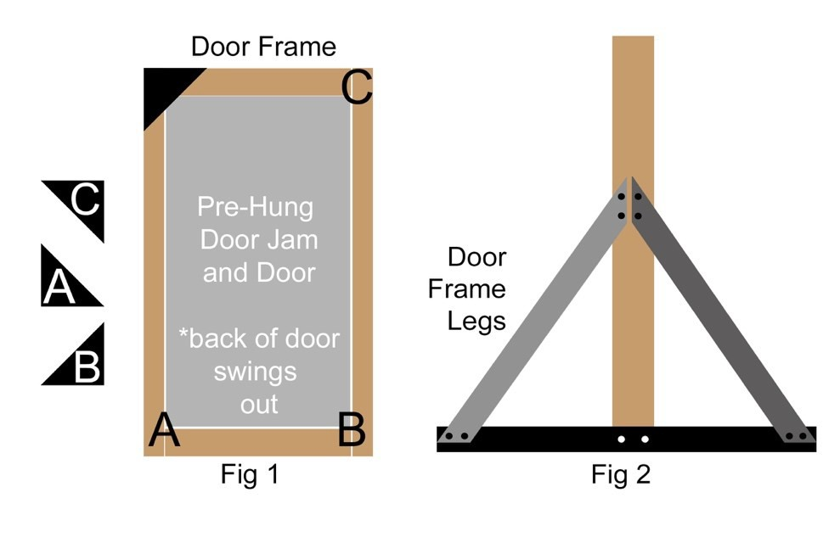
In figure (1), Step 1 Build a door frame, called your rough opening and give it supports on all four corners. Door frame supports should be installed on the back of the door. Supports are shown on one single corner, A,B, and C need to be attached.

In figure (2), Step 2 Build A frame as leg supports for the door. View is from the side. A frame includes the leg and base.

In figure (1), Step 3 Hang pre-hung door jam and door in rough opening.

Optional, add lockable, removable casters to bottom of A frame to make door transportable to any location.
TABLE OF Contents
Preface 8
The Soul-Winning Wheels 9
Four Contexts 11
The Introduction 13
The Five Steps 17
Step 1 19
Step 2 22
Step 3 25
Step 4 27
Step 5 30
Step 6 32
Conclusion 35
Resources 37

Resources
During the time that we taught this course at Sharon Baptist Church, we took seriously the hands-on time and felt that the practice of role playing greatly engendered confidence in the people. One of the tools we used to provide a more realistic experience was a prop door. This door was built from an old frame that we found located in the church storage barn. I assume every local New Testament church has an old storage barn that contains all kinds of unusual things used over the years! Most of the time these items are more often used for the purpose of providing a home for field mice than anything else! As we took this old door out, we found great difficulty getting it in place. Many times, we had to re-prop up the door as it wasn’t the sturdiest of stage props ever built! But boy, what an asset it was to make real the experience of knocking on a door and asking someone the state of their eternity! To save you from the challenges that we experienced with our door, we felt it would be beneficial to provide an easy to use set of instructions so that you might build a sturdy, stable, prop door to use as you teach this course.

burning monstrosity. How unusual, such a site, and no one but you. There are no onlookers, no sirens in the distance, just silence with the exception of the crackling of the flames against the wood. You notice in an instance a small figure broaches the window and billowing smoke on the second floor. A young child, barley able to speak cries for help! What do you do? Pretend that this is not happening? Close your eyes and wish that you were somewhere else? Convince yourself that it’s not your responsibility, or perhaps someone else will come to the aide of the young child? Maybe in your thought you might say this, “Well I’m not a firefighter, that’s not my job!”
The truth is, you and I are this bystander. We are standing outside the building that is being devoured in flames. We have the ability to save people from the catastrophe that is already occurring. But just like in our illustration we avoid our responsibility to pull those out of the flames by delivering the message of Salvation. Let us never come to the place when we forget our Lord’s last words before he ascended to the Father, “Go ye therefore, and preach the Gospel…”

Dedicated to my wife Shannon

Foreword
"Soul-Winning." Those words invoke both positive and negative feelings among local New Testament Christians in our churches today. They also bring up mixed feelings for those of us that have accepted the call to preach the Gospel of Jesus Christ to a lost world that is hell bound without the Savior.
On one hand, we desire to follow the Great Commission and our Lord's admonition to reach the whole world with the Gospel. We quote Mark 16:15, "And he said unto them, Go ye into all the world, and preach the gospel to every creature," as if it was some kind of credo we adhere too if we going to be a great Christian. We get excited at the prospect of people from other nations, tongues, and worlds apart from ours, receiving Christ as their Savior. The DVD's our missionaries on the foreign field show us moves our hearts and our souls are stirred once again to reach the lost. Not one Christian would dare say, "I don't want to win my family, friends, loved ones, and colleagues to the Lord, let them die and go to hell." So, on one hand the word "Soul-Winning" is as a positive word and a good thing in our lives.
But on the other hand, the word "Soul-Winning" brings up negative feelings. Not in the sense that Soul-Winning is a bad thing, but more of a realization that if we are going to fulfill the Great Commission that "I" have a responsibility to share the Gospel with the lost. It's the "I" thing that most Christian's don't like. Their comfortable if the Pastor or the staff of the local New Testament Church goes Soul- Winning, perhaps even the deacons and Sunday School teachers, but not "me." "I can’t do that or I don’t know what to say," are the usual

Conclusion
In closing, Soul-Winning is our responsibility. God did not commit the Gospel to angels, but rather you and I. I believe that the multiplication we see in the book of Acts is attributed to the fact that every born-again child of God took serious their role in spreading the Gospel. It should not be that just Pastors, Deacons, and Evangelist are proclaiming the truth of Salvation through faith in our Lord Jesus Christ. Imagine what the Lord would be able to accomplish through His people if they would be obedient and engaged personally in this matter of personal evangelism. Untold millions are still lacking the Light, they are lacking the Bread of Life, they are lacking the Way, the Truth, and the Life. Let’s take seriously this call to spread the Good News. I pray this short course will be a refresher to you and your church family! Could we ever press ourselves too much in our efforts to reach the unsaved of this world?

I would like to close with this illustration: Imagine for a moment you were walking down the street. As you go along you notice, much to your surprise a building on fire. As you approach this building you are drawn to the spectacle of it. You stand with your mouth agape, wondering how long this frail structure will last in the face of the leaping flames. The heat from this large fire causes just a little bit of sweat to begin beading upon your forehead. As you stand there, it occurs to you something unusual is taking place. You look to your left and to your right only to discover there is no one around but you and the

- Ask them if they have a Bible to read, if not offer to get them one if they do not have one. – One cannot grow in the Christian life without the word of God.

- Congratulate them on the life changing step. – Show them how exciting this life changing step truly is. If at all possible take them to your Pastor and let them tell the Pastor what they have just done. This will do them good, and certainly will encourage the heart of your Pastor!
words that proceed from the average church members heart and mouth. (Matthew 15:8)
This book "Showing People the Way to God" is a way to break down the barrier between the positive and negative feelings of " Soul- Winning." It is not another Soul-Winning course in the quagmire of systems, plans, and choices that are available to the pastor and the local New Testament church. This is a helpful tool to be used by the most experienced and novice Soul-Winners. At our church, we billed it as aSoul-Winner’s Refresher Course and taught it in two consecutive weeks on Monday evening and Wednesday during the prayer and bible study time. This six-step lesson plan will guide you through a simple, and systematic approach to Soul-Winning that places and emphasis on thought provoking questions and direct conversation with the lost. I know you will find this to be a great benefit for those in your church, just as I did. Soul-Winning does not have to be both "positive" and "negative" to Christians. This book will aid in making it a powerful and positive emotion for all.

Pastor David Carroll
Senior Pastor Sharon Baptist Church

Preface
First off, I would like to express a sincere appreciation and love to my best friend, my wife. She has been the best Soul-Winning partner anyone could ask for. She has supported me, encouraged me, and loved me in both the good times and the bad. It is only by her help that I am able to minister in any form or capacity! Also, let me take this moment to thank Pastor David Carroll, the Senior Pastor of Sharon Baptist Church in Hampton, VA, for his encouragement, mentorship, and fellowship. He has taught me how to minister to God’s people not only through one on one mentorship, but also through his daily life example. This course you are about to read is designed to be used either by an individual, by a couple, or as we have used it here at Sharon Baptist Church, by the Outreach Director/Pastor to refresh the congregation in this area of personal evangelism. The first two chapters lay the foundation for the entire course and its focus. The remaining eight chapters focus on the process of personal evangelism. The strength of this course will lie in the sections marked “time to take action”. During this course when you arrive at those sections, you will be asked to discuss and role play certain portions of the Soul-Winning process within different contextual life situations. Taking time to role-play is a vital necessity for both the veteran Soul-Winner as well as the beginner. Sharon Baptist Church found it was very helpful to cover this course over a four-day period, around one hour block of instructions/hands-on per meeting.
If you would like our team to come and teach this course at your church please contact us at:
churchoffice@sharonbaptisthamptonva.com.
us today, in a comfortable kind of lukewarm Christianity that is not pleasing to the Lord Jesus Christ.

So, what are these “next steps” for a Christian? Well here are a few
that I believe are indispensable:
- Reiterate one-time salvation. (Difference between fellowship and relationship.)

- Explain that they are eternally secure, preferably by scripture.

John 3:36, Romans 10:13

- Encourage them to the next steps.
  - Church Attendance – Explain that they should attend church regularly. (And a Public Profession of Faith – If won outside a church service.) Hebrews 10:25

  - Baptism – Explain briefly what Baptism is, and that you will follow-up with them about this next step. Matthew 28:19

  - Discipleship – Explain briefly that they should consider learning more to help them grow and lay a foundation. Every local New Testament church should have a discipleship program of one form or another. If we do not disciple we are not performing the Great Commission in its entirety according Matthew 28:20

- Warn them about the warfare! 2 Corinthians 10:4, 1 Timothy 1:18

Step 6

“You’re not done yet”
S

tep six is the secret step of the Soul-Winner because as infrequently as it is performed you would think that it is a secret! This step however, is vital after a person has accepted Christ
as their Saviour. Imagine for a moment that you have a baby born into your family. Imagine taking that baby and not doing anything to help it, even though you are its parents. Imagine now some criminals taking that newborn baby and raising it with everything wrong they could possibly think to teach it. Later on, as this child grows up it will start to perform that which it is taught and with no other foundation and will have a hard time dealing with right and wrong! This is how important Step 6 is. The Bible is clear that when someone gets saved they are “born again” (John 3:3). We find this truth in looking at the account of Nicodemus’ encounter with Jesus. That encounter coupled with Paul the Apostles and Peter’s reference to the milk of the word (1 Corinthians 3:2, 1 Peter 2:2) and the meat of the word (1 Corinthians 3:2, Hebrews 5:12), we get the picture that a brand-new Christian is just like a new born babe.

We should understand then, as this newly saved Christian sits in front of us, that there are some things that they need to be taught to them. If we fail in this Step, we are just like the picture given above, taking a newborn and allowing the world to influence their life without any foundation being laid. The result of not growing is prevalent around

The Soul-Winning Wheels
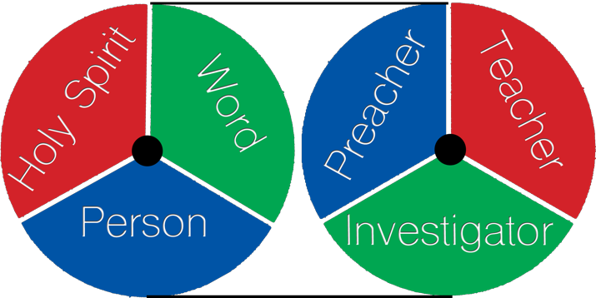

n Romans 10: 14-17 we find that the Bible gives us an indication as to how the Gospel will go out. These two wheels are based on this passage of scripture as well as what we find throughout the Gospel
I
records, particularly John.

The wheel on the left represents what needs to be present and involved in the salvation of a person. Those are: The Holy Spirit, The word of God, and The Person (the Soul-Winner).

The Holy Spirit: “he will reprove the world of sin, and of righteousness, and of judgment:” John 16:8, John 6:44, John 6:65, John 3:5

The word of God: “So then faith cometh by hearing, and hearing by the word of God.” Romans 10:17

The person: “How then shall they call on him in whom they have not believed? and how shall they believe in him of whom they have not heard? and how shall they hear without a preacher?” Romans 10:14

The wheel on the right represents what a Soul-Winner needs to be: A Preacher: One who proclaims the Gospel message.
A Teacher: One who can defend the truth, explain the truth, and correct false assumptions or doctrine.

An Investigator: One who asks fact finding questions to determine a
person’s understanding of the Gospel message.

The focus for this refresher course will be on all three of these areas however, special emphasis will be on the last area which is that of an investigator.

Take a moment and discuss the two Soul-Winning wheels.

Along with understanding the two wheels of soul-winning, we will be role playing through four different contextual life situations.
Leading the person in a prayer does not mean you have to pray for them [the “sinner’s prayer”]. The preferred method is to have them pray and to have them pray out loud. It may be wise to inform them you are going to open the prayer and pause for them to pray. Reiterating the points in your prayer is not a bad idea, then pause and let them speak to God from their heart. If there is a long pause and you feel it is time to close the prayer, close it and ask them if they ask Jesus to save them. Ask them this question “ if you were to die today would you go to Heaven?”

Is it inherently sinful to pray for someone? I do not believe so. However, I believe it will work out in the end better if that person prays for themselves. One reason I say this is because at some point when our Adversary tries to make them ineffective for Christ and let’s say they find themselves in a backslidden condition and do not feel saved, they will better be able to go back to a time and a place where THEY prayed and asked Jesus to save them. Of course, the goal is for that never to happen, which brings us to the secret Step number 6.

Before moving on, practice all 5 Steps, including transition statements. Remember, the more time you spend practicing, when the time comes the better you will be prepared!

Step 5

“Ask Jesus to save you”

tep five is where every soul-winner desires to get to and is also an awkward place to be if you do not frequently make it all the way there. This point can be simple enough, or might take
S
some great leading depending on the background of the person you are engaging or even the age of the person you are talking with.

Romans 10: 13

For whosoever shall call upon the name of the Lord shall be saved.
Some fact-finding questions to ask for step 5 might be: How do you call upon the name of the Lord?
How do we call upon the name of the Lord? Would you like to call upon the name of the Lord?
What does God’s word say will happen if you call upon the name of
the Lord?
Have you ever prayed?
Do you know what prayer is?

When we taught this course at Sharon Baptist Church over four days, this note was included in the notes that should be helpful:

Four Contexts
our life situations present themselves to all people. During this refresher course you will be asked to team up with a partner and perform some role-playing. During this time, you
F
will be putting into action what has been covered up until that point. These four contexts should accurately depict just about any possible situation you could run into as a Soul-Winner. Therefore, it is advantageous for us to know how to introduce the conversation of a person’s eternity, and continue through the six steps that will follow assuming the person who you are talking with desires to be saved. Too often, we do not prepare for these different life situations. Because of this we fail to be a bold witness for Jesus Christ.
The four contexts are:

Family Member
Co-Worker (Substitute class-mate for younger people) Church Visitor
Random Person
Depending on the situation and the person’s background, the introduction and initial steps may be different, but as you get farther along in the steps your conversation within these different contextual life situations should become more similar.
For example, talking with a random person, my introduction will certainly be different than if I am talking with a family member. A co-worker may

be dealt with differently based on what you already know about that person and the type of relationship you have with them as compared to a random person. What about a church visitor, will I start my introduction the same way I would a family member that I have known for 20 years? Probably not. What about if someone walks the isle to the altar to be saved? Where do I begin?

Take a few moments and discuss these four contextual life situations.

Think about what needs to be present in leading someone the Lord and also what you and I need to be as a Soul-Winner. With the wheels of Soul-Winning and with these four contextual life situations we can now transition to the introduction.
This of course is when you would turn over to Romans 10:13 for the final step.

Practice Steps 1-4 with the transition to Step 5. Groups of two can trade of role-playing based on the different contextual life situations.

precipice of being saved, yet as bad as we want that person to make a decision for Christ, it must be made by them.
Some fact-finding questions to ask for Step 4 might be:
What do you have to confess? What does it mean to confess?
Do you really believe in your heart?
Why do you think it says confess with the mouth and believe in the heart?
Can I know what you are thinking right now? Can you know what I really believe?
Did you realize that God knows your heart?
Did you realize God knows what you really believe? Do you see the two parts spoken of here?
Would you like to ask Jesus to save you?
If you understand everything we have talked about up to this point, would you like to ask Jesus to save you?
In transitioning from this point to the next it may be wise to review all that has been covered. By the way, there is never a bad time to reiterate what has already been covered.
It may sound like this, “John we saw first of all that we are all sinners, secondly that because of that sin, if we were to die by ourselves with nothing else the consequence is spending an eternity in placed called Hell, separated from God forever. We also saw from God’s word that God loves you and sent His only begotten Son Jesus Christ who died on a cross for your sins and mine, and as the Bible says He rose three days later from the grave. We also, just saw that God knows are heart and that is where belief begins. John, would you like to receive this gift of salvation?”

The Introduction
erhaps the introduction is one of the most difficult parts of being a bold witness for Jesus Christ. It certainly can be one of the most awkward. Particularly if we are not prepared for
P
the situation that presents itself in one of those four contextual life situations. As we progress through these steps our goal should be to talk less and listen more. Too often the soul-winner gets into a rut, going through the tried and true method that he or she has been taught. Perhaps this is when the Soul-Winner goes into autopilot. Maybe for the one who has recently learned the Roman’s Road or John’s Road they quickly navigate through their Soul- Winning steps only to find a checked-out look, a look of “I don’t understand you” or even worse, the look of I am just being hospitable by listening to you. Maybe you been there before, you have “lead someone to the Lord” only to find in the weeks and months to come, that perhaps they never really “got saved.” Certainly, if you have been witnessing for Jesus for any length of time, you probably have experienced one of these responses if not all of them. Let me encourage you to think more, investigate more, and speak less.
What will be provided in the following chapters is not a script to memorize but rather an admonition to think through these different contextual life situations and then use some of the provided fact- finding questions to discover where a person’s heart and thoughts are as it concerns the Gospel message.

With that being said, What are some statements coupled with questions that you would use to introduce yourself and perhaps your soul-winning partner in these four contextual life situations?

Take some time to think about these questions/statements and then discuss it.
Below you will find a list of questions. This list is by no means an exhaustive list, but just some question that may fit the different situations you may run into. Discuss these questions at great length and find out what introduction statements and questions you would use toward a: Family Member, Co-Worker, Church Visitor, or Random Person.
Here are some questions to think about and discuss:
Do you know that if you were to die today you would spend an eternity in Heaven?
(If Yes) How do you know that?
Do you know Jesus as your personal Saviour?
(If Yes) Tell me, where did you get saved? Or Tell me about when you got saved?
What is your church background? Did you grow up in church?

Step 4

“Do you believe”

tep four really could be classified as the heart searching step. It is at this point that you are wanting to see the heart of the person you’re talking with as much as they will allow you to
S
see it. Consequently, it truly is the heart that matters! A possession of salvation is needed not a profession!

Romans 10: 9-10

That if thou shalt confess with thy mouth the Lord Jesus, and shalt believe in thine heart that God hath raised him from the dead, thou shalt be saved. For with the heart man believeth unto righteousness; and with the mouth confession is made unto salvation.
Some of the questions below will facilitate a conversation to explain that you cannot see their heart and neither can they see yours. The truth then that should be driven home is this, you might fool me and everyone else, but God will never be fooled by a false profession of faith. Also, it’s a time to let the lost person know that this is something you cannot do for them, even as much as you would like to. My wife and I have known people that we would like to see saved so bad we could taste it. And it seems at the time that they are on the

who have a distorted or heretical view of who Jesus is. This is the point in which we deliver the accurate picture of who Jesus is from God’s word.

Some fact-finding questions to ask for Step 3 might be:
Do you know who Jesus is? Do you know what Jesus did?
Do you understand that Jesus took your place? Do you believe that Jesus is who he said he was? So why did Jesus die on a cross?
Do you believe that God loves you?
Do you believe that Jesus rose from the dead after 3 days? Do you believe Jesus died for you?
The last question might be a good transitional question to ensure the person you’re talking to understands what you have just explained. In our on-going example, “John, do you believe that Jesus died for you?”

Take some time and practice Step 2 and the transition to Step
3. Groups of two can trade of role-playing based on the different contextual life situations.
What do you think will get you to Heaven? What do you believe will get you to Heaven? What are you trusting in to get you to Heaven? When did you get saved?
Where did you get saved?
Would you like to know for sure that you would spend an eternity in Heaven?
Would you like to trust Jesus as your personal Saviour? Can I show you from the Bible how you can be saved?

Once you have discussed these questions we must understand two things. One, the goal is always to turn the conversation toward Jesus and salvation. Number two, there needs to be a transitional statement or question to proceed to the next step. The last three questions provided give some transitional statements that I have used before.

Lastly, before we move on to the next steps, let’s look at an example of how one particular context will affect what steps we would go through. Here is the situation: someone comes forward and walks the aisle in your church service wanting to get saved following a straightforward Gospel message. More than likely, they may already understand much of what we are going to cover in the remaining sections. It may be wise to briefly review what has already been preached to them and go to the place which makes most sense in the later soul-winning steps. There are some assumptions we may want to consider when dealing with this person. They may already understand they are sinner. They may understand the consequences of their sin and their need for A Saviour. They may

even understand that Jesus is that Saviour. Your job then at this point as the Soul-Winner is to review what they already know, and show them what they don’t know. In this case, it may be to show them from the Bible how to have Jesus as their personal Saviour.

Always keep in mind that no two Soul-Winning situations will ever be the same. Because of this fact, we need to be fluid in our approach to leading someone to the Lord. Therefore, take these steps and use them where they best fit.

After the introduction takes place and the transitional questions have been asked we can move on to the core five steps in this refresher course.

Step 3

“God loves you and sent His Son to take your place”
S

tep three involves the proclamation of the Gospel. According to the Bible, the Gospel is the death, burial and resurrection of Jesus Christ. I Corinthians 15: 1-4 “Moreover, brethren, I declare
unto you the gospel which I preached unto you, which also ye have received, and wherein ye stand; By which also ye are saved, if ye keep in memory what I preached unto you, unless ye have believed in vain. For I delivered unto you first of all that which I also received, how that Christ died for our sins according to the scriptures; And that he was buried, and that he rose again the third day according to the scriptures:”
This is the point when we get to talk about our wonderful Lord and Saviour. We should strive with a pure heart to aptly and accurately reflect who the Lord is and what He has done for us!

Romans 5:8
John 3:16
But God commendeth his love toward us, in that while we were yet sinners, Christ dies for us.
For God so loved the world that he gave his only begotten son
that whosoever believeth in him should not perish but have everlasting life.
It is becoming more frequent, at least where we are, to come across more and more people who either one have never heard of Jesus or

What kind of death do you think this is talking about? Do you know what wages are?
Do you work?
Do you earn a paycheck?
Do you realize there is physical death, but also spiritual death?

Take some time and practice the Step 2 and Step 3. Groups of two can trade off role-playing based on the different contextual life situations.

These first two steps are certainly somber moments. Of course, the Soul-Winner doesn’t take joy in the fact of sin, nor the consequences of sin. Our facial expression, understanding the gravity of the situation should reflect what we are proclaiming from God’s word. We certainly do not need to emulate Jacob here where are hands say one thing, but his voice said something else.

A transitional statement that I believe I have heard Brother Jerry Ferrso teach from West Coast Baptist College is this, “John, there is sin and there is death, but let me give you some good news!”
By the way, what your about to tell them is the best news that has ever been told! What a privilege to be an ambassador for Christ with the most precious news ever given!

The Five Steps

ive steps will be used during this course. These steps are designed for organization of our thought processes as we navigate through the process of leading someone to
F

the Lord.

The five steps we will be using are being represented by phrases to solidify in the soul-winner’s mind the main thoughts behind these steps.

Step 1 “I’m a sinner, you’re a sinner”
Step 2 “There is an expected result because of sin”
Step 3 “God loves you and sent His Son to take your place”
Step 4 “Do you believe”
Step 5 “Ask Jesus to save you”

Discuss the five steps for a few moments.
Just as a side note, there will be a sixth step that will actually be covered. It may be wise to save this sixth step as a surprise. Why? Because most of the time, this may be, to our shame the weakest area

of our Soul-Winning efforts. If at this point you skip to the end of this manual to find out what sixth step is I don’t blame you! One last bit of advice before we get into the steps, add a roadmap of scripture or memorize it! Preferably, both! This is done by starting with the first verse in your Bible and marking off to the right or left in the margin where the next verse can be found. This roadmap coupled with memorization will help your conversation to be more fluid! It certainly is a shame with the number of Bibles the average Christian has in their home in the United States, that not even one is marked in such a way that they can lead someone to the Lord. It is also a shame that a Christian who desires to follow Christ would not take the time to learn a half a dozen verses. Again, add a roadmap or memorize it! Preferably, both!
But the fearful, and unbelieving, and the abominable, and murderers, and whoremongers, and sorcerers, and idolaters, and all liars, shall have their part in the lake which burneth with fire and brimstone: which is the second death.
Three verses are given, however only one typically needs to be emphasized. Romans 6:23 will be the predominant verse used for the purpose of this refresher course. However, Romans 5:12 may be used in the case where clarification is needed on sin, its origin, and its devastation to all of man. Revelation 21:8 might be used to underscore the Bible definition of death. Not decay of this temporal body, but eternal separation from God in a place called Hell. Understanding that your temporal body is going to cease to function one day is a fact that everyone is aware of before you bring it up, but not everyone knows that there is a literal Hell, and that it has eternal consequences for the unsaved. Therefore, the term used in the Bible “second death” is very helpful.
As a side note, please slow down your speech and inflect your voice on the words you want the lost person to pay particular attention to. I catch myself all the time because of familiarity and also because of nervousness quoting the verse very rapidly in a monotone type of matter. Remember our goal is not just to be a Preacher of the Gospel, but a Teacher, and an Investigator. We need to do everything possible to communicate the truth!
Some fact-finding questions to ask for step 2 might be:

What do you think this verse is saying?
You agreed earlier that you were a sinner, right? What does the Bible say we earn because of sin?
Do you realize God declares what we earn because of our sin is death?

Step 2

“There is an expected result from sin”

tep two involves the “so what” of I am a sinner. A person agrees they are sinner, but “so what” so is everyone else! In a world filled with wickedness and a culture that is seemingly
S
headed off the deep end into deeper and deeper debauchery, what does this mean to the lost person you’re talking to? Well simply stated above, there is an expected result from sin. This is the central truth you are communicating from God’s word. Unfortunately, this is perhaps why Atheism is so popular, and perhaps why so many do not get saved. After all we are told in John 3: 19-20 “And this is the condemnation, that light is come into the world, and men loved darkness rather than light, because their deeds were evil. For every one that doeth evil hateth the light, neither cometh to the light, lest his deeds should be reproved.” In other words, we could say this, man does not want morale accountability to the Creator. This may be the step that most will part company with you, but then again maybe not.

Romans 6:23, 5:12
Revelation 21:8
For the wages of sin is death; but the gift of God is eternal life through Jesus Christ our Lord.
Wherefore, as by one man sin entered into the world, and death by sin; and so death passed upon all men, for that all have sinned:

Step 1

“I’m a sinner, you’re a sinner”
S

tep one follows the introduction and really is the start point to a lost person understanding their need for salvation. Again, let me stress that some steps may not be covered but rather
reviewed depending on the situation. However, without doubt, every person needs to understand this truth in terms of salvation.

Romans 3:10, 3:23
“As it is written, There is none righteous, no, not one:” “For all have sinned, and come short of the glory of God;”

An opening statement that naturally leads into using God’s word in leading someone to the Lord might go something like this, “There are several things we must understand to go to Heaven one day. First of all, God’s word says” and then start reading Romans 3:10 and 3:23. This is why it is important for us to understand what must be involved in the winning of a Soul to Christ. The Holy Spirit, the word of God, and the person.
My personal preference is to use the phrase “God’s word says” versus “The Bible says”, however either statement will do.

Then in keeping with the form of this refresher course, I generally will follow up with a few questions. The first question listed in the below list is probably my personal favorite that I believe will really

show where the person’s heart is at this particular moment as the lost
person is confronted with the knowledge that all are sinners. Some fact-finding questions to ask might be:

What do you think this verse is saying?
Do you realize that you are a sinner? Have you ever sinned?
Do you know what sin is? Have you ever lied?
Have you ever stolen anything? Have you ever cursed?
Did you ever disobey your parents growing up? Have you ever had bad thoughts about others? Would you be willing to admit you’re a sinner?

Take some time and practice the Introduction and Step 1. Groups of two can trade off role-playing based on the different contextual life situations.

This very first question can be very effective in determining a person’s
level of understanding throughout all Five Steps. Once we ask the
question, our next responsibility is to actively listen! The conversation should be able to be transitioned by asking perhaps the last question in this list. I would also suggest making these questions personal by including the person’s name in them. For example, the transition might sound something like this, “John, you understand that God’s word says that everyone is a sinner, you’re a sinner and I am a sinner. John, would you be willing to admit that you are a sinner?”

If the answer is yes, then your free to precede to the next step. If the answer perhaps is no, this may be the opportunity to circle back around with some more fact-finding questions. In the rare event that someone is unwilling to admit they ever committed wrong, the session terminates. The job of the soul-winner then becomes leaving the door open for the next person, or you at a later time to still lead them to the Lord. And secondly, leave the person with an understanding of where they stand before God.

